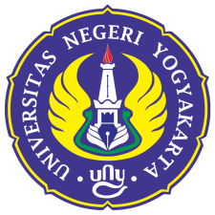 | UNIVERSITAS NEGERI YOGYAKARTA  FACULTY OF MATHEMATICS AND NATURAL SCIENCES  DEPARTMENT OF PHYSICS EDUCATION  PHYSICS EDUCATION STUDY PROGRAM  Colombo Street Number 1 Yogyakarta 55281  Telephone (0274)565411 Ext. 217, fax (0274) 548203  Web: http://stat.fmipa.uny.ac.id, E-mail: fisika@uny.ac.id

Bachelor of Physics Education | MODULE HANDBOOK

Module name: | Module name:
Module level, if applicable: | Module level, if applicable:
Code: | Code:
Sub-heading, if applicable: | Sub-heading, if applicable:
Classes, if applicable: | Classes, if applicable:
Semester: | Semester:
Module coordinator: | Module coordinator:
Lecturer(s): | Lecturer(s):
Language: | Language:
Classification within the curriculum: | Classification within the curriculum:
Teaching format / class hours per week during the semester: | Teaching format / class hours per week during the semester:
Workload: | Workload:
Credit points: | Credit points:
Prerequisites course(s): | Prerequisites course(s):
Course Outcomes | Course Outcomes
Content: | Content:
Study / exam achievements: | Study / exam achievements:
Forms of media: | Forms of media:
Literature: | List of References

PLO and CO mapping

 | PLO1 | PLO2 | PLO3 | PLO4 | PLO5 | PLO6 | PLO7 | PLO8 | PLO9
CO1
CO2
CO3
CO4
CO5
CO6
CO7

